Dunnigan Fire Department Commissioners Meeting 6/12/24 Chiefs Report.

* Tablet Command System is up and running in Yolo County and we will be transitioning our operations in the next few weeks. This will be used to provide real time data to incident commanders and Yolo County dispatch as well as reduce radio traffic. Radios can still be utilized as a backup.
* Call data for 2022 and 2023 has been accumulated and supplied.

**January – December 2022 Call Data**



**January – December 2023 Call Data**

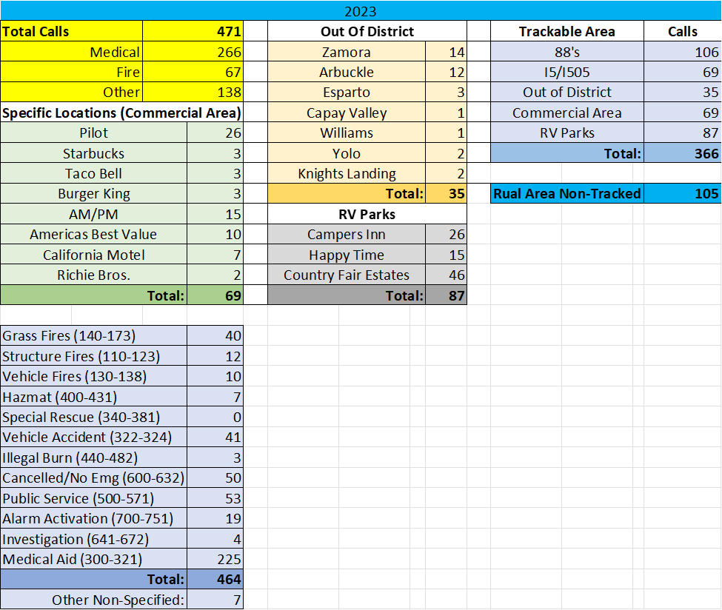

* 5 individuals completed their driver operator 1a class and have now begun working on their driver training within the department. Until fully signed off, firefighters do not operate units without an officer unless authorized by the fire chief.
* Contacted FAS fire concerning delivery date of our new type 1 engine, they advised that they are finally getting caught up from the supply delays and labor problems caused by COVID-19. Our unit’s chassis completion is scheduled for 11/11/24 and we should be taking possession of the unit around Christmas time.
* West Plainfield fire attempted to raise the CPI on their prop 218 tax as other departments were attempting to go to ballot. This caused many problems politically and numerous county fire chiefs requested they readdress their decision. They ultimately decided not to raise the CPI.
* Still working to secure a meeting with community members to address financial direction for the department.
* Sewar system for the hall is moving forward. Yolo Plumbing was given the information on Hall capacity.
* New shift officer has been hired. David Caraveo applied for the position and was interviewed on 6/8/24. He will be brought on as a Lt. and carries with him an immense background in the areas of training, operations, and administration. Neighboring fire chiefs were consulted prior to his hiring and we feel that he will be a resource to the whole county as well as Dunnigan Fire.
* Request for funding to assembly woman Agular-Curri has been itemized and priced. At this time it needs to be put together as an official request for submission.

