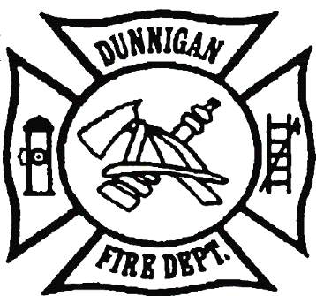COMMISSIONERS FIRE CHIEF

Anita Tatum- Chairman David Garrison

Neil Busch

Tim Hornbuckle SECRETARY

John Reyes Sherrill Jenkins

Vacant

DUNNIGAN FIRE PROTECTION DISTRICT BOARD OF COMMISSIONERS

AGENDA & SUPPORTING MATERIALS

Fire Station Training Hall

February 13, 2025

6:30 P.M- Call to Order

Meeting Cancelled due to a lack of quorum.

The next regular meeting will be held on March 13th at the Fire Station Training Hall.